This guideline is written to assure consistent practice for provider network members to review training transcripts from other agencies for placement of Direct Support Professionals (DSP) (also known as Direct Care Workers) in the provider network.

This information is intended as a guide to evaluate training records/transcripts. Each training record/transcript must be reviewed for content to assure the trainings are comparable and meet the required core courses listed in the attachment. If the employee is either not able to perform the job duties or does not have all the required core courses, then the appropriate training units must be assigned in the order listed in the appendix.

- The training agency name, completed trainings, and contact information must be listed on the training record.
- The training record/transcript must identify the curriculum used.
- Acceptable curriculums are:
  - CenTrain Group Home Curriculum (see appendix).
  - “Providing Residential Services in Community Settings: A Training Guide,” Michigan Department of Human Services, 1995.
  - “Department of Mental Health Group Home Curriculum,” Modules 1-14, 1984. This training is acceptable if there has been refresher training completed, which reflects current Michigan laws, practices, and guidelines. Supplemental training required would be Person-Centered Planning (PCP), Recipient Rights, Self-Determination, and Positive Behavior Supports, which includes: non-aversive and positive practices to support choice, control, and independence for the individual.
  - Additional Direct Support Professional training for Certified Facilities Alternative Curricula can be found at:
http://www.michigan.gov/dhs/0,4562,7-124-5455_27716_27717-251002--,00.html.
- Transcripts from a community college or university that cover the core courses listed in the attached “Required Core Curriculum Training” are acceptable.
- Certified Nurses Aid training (CENA/CNA) is an acceptable equivalency for the Health Intervention Unit. It is recommended that the DSP receive training on the requirements for Special Certification Adult Foster Care (AFC) residential programs, if applicable, as there are different rules for health care facilities for the aged.
- If the training completion date is over five years old and the employee has not been working in the direct support field of service, then all units of the training must be repeated.
- The training record/transcript must include the courses/modules/units, date of completion, and pass/fail. Successful completion is considered to be 80 percent. Scores may show on the training record/transcript as a percentage, “pass,” or an “S” for successful completion. If the record indicates “credit” was granted, there must also be a notation that indicates why credit was given or where the DSP obtained the credit.
- All required training is listed on the attachment. Review the training record/transcript to assure that all the required core courses/units were completed or that comparable courses from approved curriculum noted above were completed. The following brief descriptions of content will assist with determining whether other courses are comparable and meet state requirements:
- Cardiopulmonary Resuscitation (CPR) and First Aid (FA): This course teaches how to respond in an emergency situation and how to provide basic first aid techniques until Emergency Medical Service arrives. Most programs offer a card or certificate of completion, which includes an expiration date. Typical sources for training include: Red Cross, American Heart Association, Green Cross, and American Health and Safety Institute. The Department of Human Services requires completion of a written test and a demonstration of CPR/FA skills is included in the training for staff working in AFC homes that have a special certification license. Most CPR/ FA programs offer Bloodborne Pathogen, Preventing Disease Transmission, and Standard Precautions training.
- Safety and Fire Prevention: This unit covers prevention, preparation, and responding to emergencies in the residential setting. It also includes teaching individuals with disabilities how to be prepared in emergencies and covers documentation requirements. This training may be listed on the training record/transcript as: Environmental Emergencies: Preventing, Preparing and Responding, or Fire Safety and Environmental Emergencies.
- Rights of Recipients of Mental Health Services: Michigan Department of Health and Human Services (MDHHS) Recipient Rights Module (Revised 7/09) is the only acceptable curriculum for this training (Link: ORR Group Home Training Curriculum 7/09). DSPs must complete a CMHCM-approved Recipient Rights training. This training focuses on the rights of recipients of mental health services contained in the Michigan Mental Health Code and the recipient rights requirements contained in AFC Administrative Rules 400.14304(1-2) [400.15304(1-2)] and 400.14311(1-7) [400.15311(1-7)]. Topics Included in the unit are reporting requirements; the Adult Protective Services Act; Act 280; confidentiality; informed consent; definitions of abuse and neglect; and reporting abuse and neglect; Americans with Disabilities Act (ADA); and the Michigan Whistle Blowers Protection Act.
- Person-Centered Planning: This unit covers the philosophy and guiding principles of PCP and the role of the DSP in the PCP process.
- Introduction to Community Residential Services and the Role of the DSP: This unit helps DSPs understand community residential services and how to provide quality supports and services to individuals with developmental disabilities and mental illness. It also includes definitions of developmental disabilities and mental illnesses; and explains recovery, choice, and quality of life; and documentation skills.
- Introduction to the Special Needs of Individuals with Developmental Disabilities or Mental Illness: This unit defines developmental disabilities and mental illnesses, known causes, and characteristics. Introduction units may be taught together and may show on the training record/transcript as: Introduction to Residential Services or Introduction to Community Residential Services/Your Role as Direct Care Staff. The role and responsibilities of a DSP and the definitions and types of mental illness and developmental disabilities must be covered in the course.
- Health Interventions: Hygiene, Infection Control, Nutrition, Food Preparation, Special Diets, Signs and Symptoms of Illness or Injury, Measuring Vital Signs: The health intervention unit contains mini units on each of the topics listed above. Training records/transcripts may list multiple units on the topics or they may be grouped together in one unit such as a Nutrition course, which would include food preparation, special diets, food safety, and food handling. A Basic Health unit would include hygiene, infection control, signs and symptoms of illness or injury, measuring vital signs, and infection control. The DSP must complete a written test and some topics require an additional test referred to as a return demonstration where the DSP must demonstrate their ability to perform the skill. Measuring vital signs requires that the DSP demonstrate their ability to take a set of vitals. The return demonstration must be documented on the training record/transcript.

- Medications: This unit teaches the DSP how to administer, record, and document medications in a licensed residential setting. Topics included in the unit are: the five rights, definitions, documentation, medication errors, storage, packaging, and disposal of medications. This unit requires a return demonstration and completion of a written test.
- Positive Approaches/Challenging Behaviors/Non-Aversive Techniques and Crisis Intervention: This unit focuses on supports that encourage choice, control, quality of life, and healthy relationships for the individuals who live in a residential setting. Also included is information on prevention and coping strategies with an emphasis on maintaining a caring and supportive approach when addressing challenging behaviors. Additional topics included in this unit are: guidelines for effective teaching; how to use proactive options and confrontation avoidance techniques; what behavior is and what makes a behavior challenging; techniques to maintain a positive learning environment; how to create and support a culture of gentleness when providing direct support services; positive behavior support plans and how they are developed; and responding to a crisis situation. Since this unit encompasses a number of topic areas, an example listing of comparable courses has been included. The training record/transcript must have all of the following classes to meet this core requirement:
- Working with People: Introduction to Human Needs, Values, Guiding Principles, and Effective Teaching Strategies
- Working with People: Positive Techniques to Address Challenging Behavior
- Non-Physical Intervention

Approved by the Executive Leadership Team: 2/27/12
Revised: 1/2/14, 3/11/15, 12/3/15, 1/16/19

REQUIRED CORE CURRICULUM TRAINING
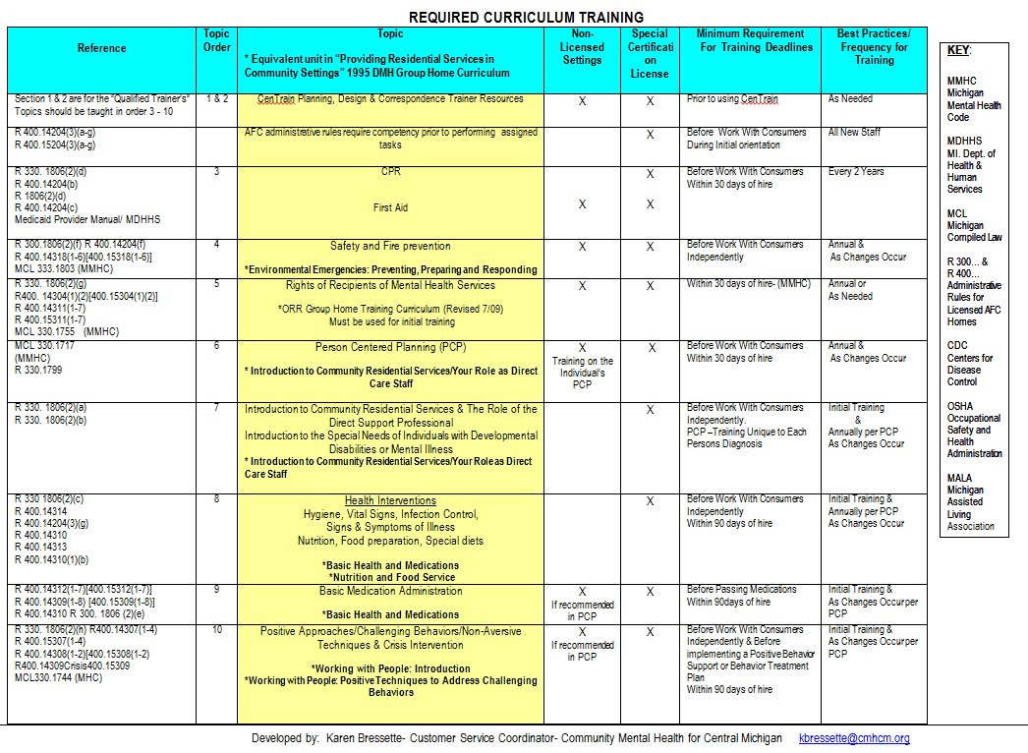

ORIENTATION & ANNUAL TRAINING TOPICS
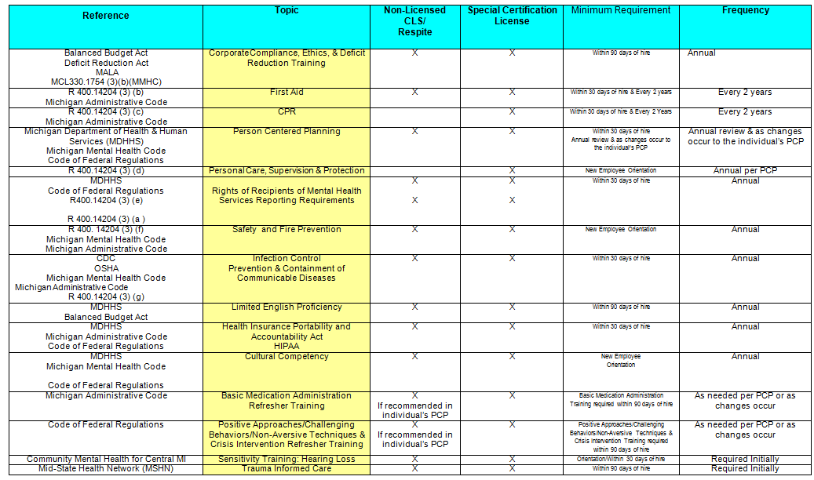
Corporate Compliance, Ethics, & Deficit Reduction Training include all the following topics: Code of Professional Ethics, False Claims Act, and Whistleblowers Act, Contact information to report suspected fraud or abuse.
Licensing Rules for AFC Small Group Homes (12 or less) https://www.michigan.gov/documents/lara/BCAL_PUB-333_7_15_-_for_web_2_497789_7.pdf
Licensing Rules for AFC Large Group (13-20) Homes http://www.michigan.gov/documents/lara/BCAL_PUB-334_7_15_-_for_web_497807_7.pdf
Licensing Rules for AFC Family Homes-http://www.michigan.gov/documents/dhs/BCAL-PUB-0332_281384_7.pdf
Developed by: Karen Bressette - Customer Service Coordinator 989-772-5938 kbressette@cmhcm.org
Community Mental Health for Central Michigan
REQUIRED TRAINING-TRAINER QUALIFICATIONS
*Consumer Trainer assists the Trainer as an auxiliary resource to share their unique perspective and/or recovery experience to support the training provided.*

